Project Design Phase-II
Data Flow Diagram & User Stories

Date | 14 October 2022
Team ID | PNT2022TMID32597
Project Name | Project – Personal Expense Tracker
Maximum Marks | 4 Marks

Data Flow Diagrams:

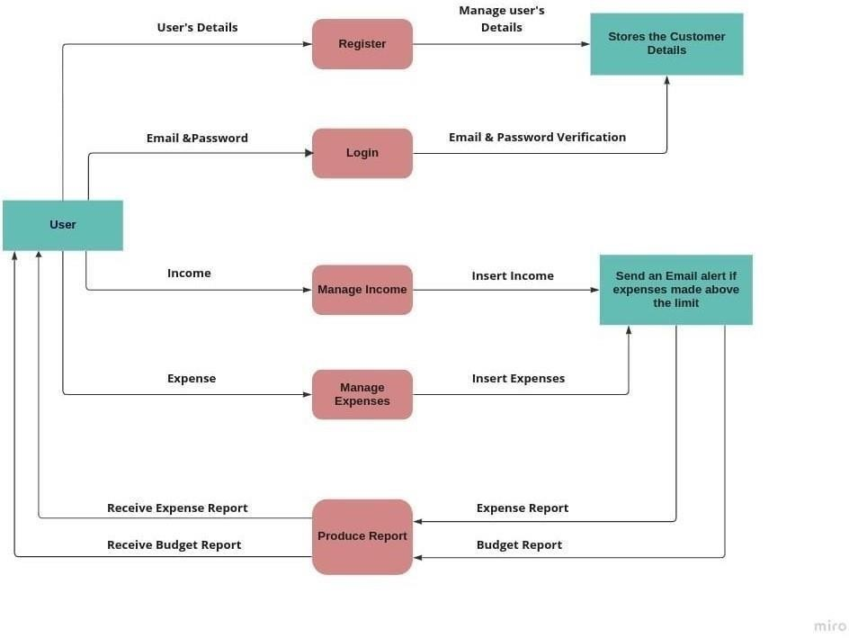

User Stories

User Type | Functional Requirement (Epic) | User Story Number | User Story / Task | Acceptance criteria | Priority | Release
Customer | Registration | USN-1 | As a user, I can register for the application by entering my email, password, and  confirming my password. | I can access my account /dashboard | High
(Mobile
user)
Login |  | USN-2 | As a user, I can log into the application by entering email & password | I can access | High
 |  | USN-2 |  | theapplication | High
Dashboard |  | USN-3 | As a user I can enter my income andexpenditure details. | I can view my | High
 |  | USN-3 | As a user I can enter my income andexpenditure details. | dailyexpenses | High
Customer | USN-4 |  | As a customer care executive, I can solvethe log in issues and other issues of the application. | I can provide support or solution at any time  24*7 | Medium
Care
Executive
Administrator | Applica,on | USN-5 | As an administrator I can upgrade or update the application. | I can fix the bug which arises for the customersand users  of the application | Medium

